

HomoRoboNet :Deep Learning for Recognition of Humans vs Robot Face Images
Developed By:
Ranya Emad Muharab Alsheikh
Tala Nabeel Ahmad Daoud
Esraa Zakaria Nimer Hindi

Supervised By:
Dr. Rasha Al-Bashaireh
Computer Science Department
Faculty of Information & Communications Technology
Tafila Technical University
Fall 2024-2025

ACKNOWLEDGMENT

We extend our sincere thanks to everyone who taught us a letter at our prestigious university, Tafila Technical University, to the professors of the College of Information Technology, without whom we would not have reached and learned, and they played a major role in most of what we have achieved today. We also extend our sincere thanks to our family, who were the constant support in our academic journey throughout the past four years, and now we are on the verge of the end of the four years, to my great parents who form the basis of our success, as our family's encouraging words are what caused us to reach the end of the journey today.
A big thank you to Engineer Ahmed Abu Zneid, who played a role in inspiring us with the idea of ​​our project today when we were in our university training, and he and the rest of the engineers in the company played a major role for those who helped us and we learned a lot from them.
Thank you to all our university friends without exception, with whom and through whom this journey was completed.
We extend our special thanks to Dr. Rasha Al-Bashaireh, our project supervisor, who played a major role in bringing our project to this stage, as she was the great supporter for us to excel and innovate in our project.
Thank you to the professors of the Computer Science Department All of them played a major role in developing our project idea. Their advice and words were of great value. We are now on the verge of the end of our academic journey. Thank you to everyone who supported, encouraged and contributed to our reaching the end. Thank you all.

TABLE OF CONTENTS
CHAPTER 1. INTRODUCTION
  - Problem identification………………………………………2
  - Problem background and Related Work………………3
CHAPTER 2. DATA
Dataset Description……………………………….…………6
  - Dataset Preprocessing Steps………………………………7
CHAPTER 3. METHOD
  - Methodology Framework…………………………………3
  - Model Architecture and Description……………………4
  - Background on the used Algorithms……………………9
CHAPTER 4. RESULTS AND DISCUSSION
  - Experiments Setup……………………………………………4
  - Evaluation Metrics……………………………………………1
  - Experiments……………………………….………………….…2
  - Results Analysis (Visualization) and Description………8
CONCLUSION AND FUTURE RECOMMENDATION
LIST OF TABLES
LIST OF FIGURES
REFERENCES

CH 1. INTRODUCTION

1.1 Problem identification
In our current era, the development of artificial intelligence is accelerating at an astonishing pace, beyond the traditional boundaries of technical innovation to enter worlds that seem like science fiction. We are now living in a new era of “post-truth,” where truth itself has become a concept that can be changed and reshaped. This era, while it holds tremendous promise for improving our lives, also carries existential threats to the foundations of society.[1]
AI has become capable of producing photographs that are almost indistinguishable from real images, convincing texts that are indistinguishable from human writing, and voices that are very close to the original human voice. These developments are not just technical achievements; they represent a radical shift in the way we deal with reality, data, and information. Thus, image synthesis has received intense research, especially after Generative Adversarial Networks (GAN). [2]
One of the most prominent concerns arising from this technology is the ability to create digital images that resemble real people to an amazing degree, making it difficult for the average person, and even technical systems, to distinguish between what is real and what is fake. This overlap between reality and fiction poses huge ethical and legal challenges, especially in light of the increasing prevalence of the use of artificial intelligence in digital forgery and manipulation of facts.
However, it may constitute a serious threat regarding legitimacy, authenticity, and security, especially in the hands of malicious users. Malicious users may exploit this advantage to create and disseminate fake media that is well-suited to their attacks. Thus, new difficulties as a result of not being able to detect AI-generated images in the real world.[1]implementing an automated system that is able to detect and recognize GAN-generated images is significant for image synthesis models as an evaluation tool, regardless of the input modality. To this end, we propose a framework for reliably detecting AI-generated images from real ones through Convolutional Neural Networks (CNNs).[3] The GAN architecture and its variants have improved these generated images. Sometimes, these artificial images are hardly distinguishable from real images. This could help in improving the media and content in the digital world; nonetheless, it likewise comprises dangers with respect to authenticity, genuineness, and security.[3]
The inability to distinguish between bots and humans can lead to a range of problems and risks that affect various aspects of life. In the field of security, bots can be used to carry out fraudulent attacks such as financial fraud or system hacking, resulting in unauthorized access to individuals’ accounts or sensitive systems, resulting in significant financial losses and theft of sensitive data. In addition, bots can be used to spread misinformation and fake news on social media, misleading the public, influencing elections, and destabilizing social stability. On the other hand, the use of bots in online interactions can reduce the quality of human communication and user experience, which leads to a loss of trust in digital platforms and a decline in the quality of services. Bots can also be used to misuse resources through excessive requests on systems, leading to disruption or slowdown of services. In the economic context, bots can engage in economic activities unfairly, such as purchasing products in bulk before real customers, affecting the availability of products in the market and leading to higher prices. Security risks also increase as bots are used to carry out sophisticated cyber_attacks, such as DDoS attacks, disrupting systems and creating significant security threats. Failure to distinguish between bots and humans can also lead to a loss of trust in interactive systems such as customer service, negatively impacting businesses that rely on digital interaction. Unfair discrimination against real humans can lead to them being denied services or rights due to errors in discrimination, raising ethical issues related to the violation of privacy and personal rights. Relying on unreliable identity or security systems can lead to critical security errors and increase the likelihood of hacking, increasing trust issues and reliance on technology for sensitive matters.
1.2 Problem background and Related Work
Humans have always been fascinated with faces. It is how we recognize people, it is the main feature we watch out for when interacting with other people. This is reflected in the fact that we have a specialized region in our brain solely dedicated to the detection of face patterns and their subtle changes.[4] [5]
Can you distinguish between the two images appearing in front of you, which is a real human image and which is a robot?
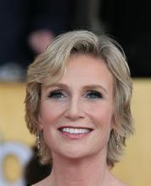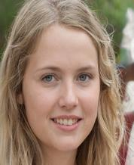
Fig.1: Human or Robot Image
Answer: The left picture is a human and the right picture is a robot.
When distinguishing between human and robotic faces using AI, many subtle details can be observed that distinguish human faces from those generated. These details include the natural wrinkles that appear with age in areas such as the forehead, around the eyes, and mouth, while robotic faces typically lack these wrinkles or appear unnatural. Also, humans have a natural skin texture that includes fine pores and blemishes, while robotic skin may appear rough or polished. On the other hand, there is a natural variation in brightness and illumination on the human face due to the skin’s interaction with light, while robotic faces display unnatural illumination. Additionally, humans are capable of displaying complex facial expressions that correspond to emotions, such as smiling or sad, while robots may display rigid or inconsistent expressions. Also, eye and eyelid movement in humans is natural and includes blinking, while robots often lack these movements or may be irregular. Fine details around the eyes, such as small hairs or natural light reflection, can also be observed, which are lacking in synthetic faces. In the nose and mouth, humans can show fine details such as small wrinkles around the mouth or nasal ridges, while robots may show a stiff, unnatural nose and mouth. Also, the symmetry of the human face is not always perfect, reflecting minor distortions, while generated faces may show unnatural symmetry. In terms of hair, human hair shows fine details such as texture and color, while synthetic faces may show inaccurate or artificial hair. Finally, artificial intelligence such as GANs (e.g. StyleGAN) or convolutional neural networks (CNNs) can be used to analyze images and detect unnatural details such as perfect symmetry or subtle optical errors that may be invisible to the naked eye.
Why is the system for distinguishing between humans and robots important?
The growing difficulty in distinguishing between AI and reality is a major source of ethical concerns, primarily due to the serious issues that could arise from the production of fake data or fabricated evidence. It will become extremely challenging to differentiate between real human images and robots. AI capabilities have reached the point of cloning not just the appearance and some movements but also creating fake images. AI can now replicate a person’s speech or writing style, imitate their behavior, and predict moods and actions, in addition to faking voice and image. This has enabled fraudsters to impersonate someone when communicating with their acquaintances, colleagues, friends, or family members, using their typical words and manner of speaking.
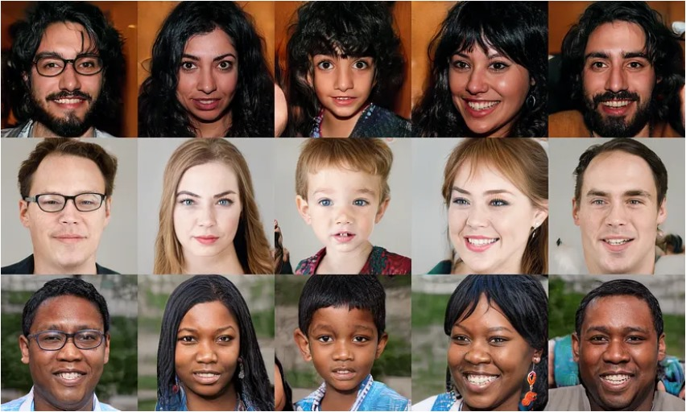
Fig.2: Fake faces generated by StyleGAN.
StyleGAN (Generative Adversarial Network) is an advanced Generative Adversarial Networks (GAN) model developed by NVIDIA, first introduced in a 2018 research paper and seen significant improvements in its subsequent versions such as StyleGAN2 and StyleGAN3. This model is characterized by its ability to generate highly realistic images using a unique architecture that separates the style of the image (high-level features) from the content (low-level features), allowing hierarchical control over the image properties and modifying features ranging from pose and shape to fine details such as texture and lighting. StyleGAN works via a feedback loop between the generator and the discriminator, gradually improving the quality of the generated images. One of the most prominent applications of StyleGAN is to generate realistic human faces for non-existent people, providing great value in training machine learning models without the risk of privacy violations. It is also used in the entertainment and media industry to design realistic characters and create high-quality visual effects, as well as to enhance or restore old or low-quality images. However, StyleGAN’s ability to create fake images poses significant security challenges, as it can be used in fraudulent schemes such as deepfakes in videos that could lead to massive financial losses or the creation of fake identities used for digital authentication. It is also used in fake advertisements targeting the public. With these capabilities, a major challenge is the lack of sufficient awareness about digital forgery among individuals, which exposes them to risks. AI also raises important ethical questions about truth and trust, requiring the development of ways to protect individuals and societies from the negative effects of these technologies.[6] The StyleGAN architecture merits the attention of a broader readership because it provides an ecosystem for a variety of applications and is used as the basis for a large number of research works.[7]
Deepfake generation can be summed up as a face-swapping operation that is not being recognizable by human viewers Deepfakes are used by artists, social media platforms, in film, game, fashion, and entertainment industry [8], [9], [10]. Refer to Section IX for a comprehensive exploration of how StyleGAN functionality can be harnessed for deepfake applications: face reenactment [11], [12], swapping and transfer [13].

CH 2. DATA

In our project to distinguish between real and fake images, two sets of data were used. The first set Celebrity Faces Dataset is data for real images, and the second set thispersondoesnotexist.10k Dataset is data for fake images.

  - Celebrity Faces Dataset
2.1. 1 Dataset Description:
The Celebrity Faces dataset contains facial images of various celebrities from all over the world. It is widely used in deep learning, computer vision, and image processing projects. Its main purpose is to provide a diverse set of facial images for training, testing, and evaluating face recognition, classification, and feature analysis models.
"img_align_celeba "is part of the "CelebA" dataset, which contains a large set of aligned images of celebrity faces, where the faces are centered, making them easier to process by deep learning models. This set includes around 202,599 images of 10,177 celebrity faces. The images are of medium resolution (178x218 pixels), and are aligned in a consistent manner so that the positions of the eyes and mouths are uniformly aligned. Despite the centering, the images retain good variation in angles and lighting, which enhances the generalization abilities of the models. These images are used to train face recognition models, such as CNNs, to analyze or classify facial features, and are also used in face generation tasks using techniques such as GANs to improve the quality of the results thanks to uniform alignment. The "CelebA" dataset faces several challenges associated with it. First, there is limited diversity, as the dataset may lack sufficient ethnic or age diversity, which can affect the ability of models trained using it to generalize well across diverse populations. Second, there may be bias due to focusing on celebrities from specific regions or age groups, which can negatively impact the accuracy of models when applied to broader images or populations. Finally, copyright is a challenge, as the dataset contains images of real people, which raises issues of privacy and usage rights, and these issues must be taken into account when using the dataset for research or commercial applications.
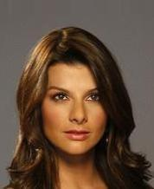 | 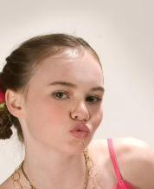 | 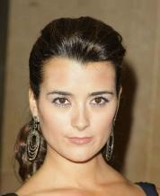
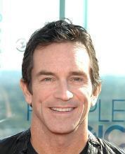 | 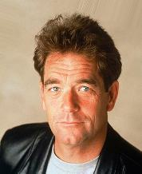 | 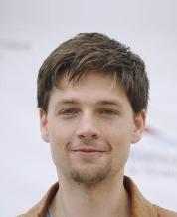
Fig.3: Celebrity Faces Dataset.
2.1.2 Number of Samples:
- The dataset includes thousands of images.
- Images are grouped by individuals, with multiple images per celebrity.
2.1.3 Image Details:
- Resolution: Image resolution ranges from low to medium, with some datasets offering high-resolution images.
- Dimensions: Common dimensions include 178×218 pixels, but other sizes may also be available.
- Format: Images are typically in JPEG format.
2.1.4 Image Content:
The dataset focuses on facial features and typically includes:
- A wide variety of expressions, angles, and lighting conditions.
- Diverse demographics covering different ages, genders, and ethnicities.
- Various scenarios, such as smiling, serious expressions, or side views.
- Backgrounds that may vary or be simplified for easier processing.
2.1.5 Dataset Sources:
Celebrity Faces Dataset often refers to several widely used datasets, such as:
- CelebA (CelebFaces Attributes Dataset):
- Contains over 200,000 images of around 10,000 celebrities.
- Includes attributes like gender, glasses, smile, hairstyle, and more.
2.1.6 Applications:
- Face Recognition.
- Attribute Analysis.
- Classification and Segmentation.
- Generative Modeling.
2.1.7 Advantages:
- Includes numerous attributes like hairstyles, glasses, smiles, and expressions.
- Covers a wide range of ages, ethnicities, and genders.
- Suitable for deep learning tasks due to its large size and labeled data.
- Freely available for academic and research purposes.
2.1.8 Challenges:
- Privacy Concerns: Some versions may require specific permissions for commercial use.
- Bias in Data: The dataset may exhibit biases in race, age, or gender distributions depending on the source.
- Image Quality: Certain images may be of lower quality or contain distracting backgrounds.

  - thispersondoesnotexist.10k Dataset:
2.2. 1 Dataset Description:
It is an innovative dataset containing 10,000 high-quality images generated using advanced AI techniques, specifically generative adversarial networks (GANs) such as StyleGAN. The images in this set are so realistic that it is difficult for the human eye to distinguish them from real photographs of real people. However, the people whose faces appear in these images are not real, but rather these faces were designed using generative algorithms to resemble real human individuals in terms of features and fine details such as eyes, mouth, and nose, in addition to the different emotional expressions that appear on the faces. This set is very useful in many technological and scientific applications. For example, it can be used to train face recognition models, as it provides a variety of images that can help improve the accuracy of models in distinguishing between faces. It can also be used to analyze images or generate digital faces for use in games, movies, or digital applications that require human faces specifically. It is also used in testing security systems such as facial recognition systems, as it provides a set of fake images that can be used to test the system’s ability to distinguish between real and fake images. One of the major benefits of this set is the wide variety of images generated, as faces can be created that represent a variety of ages, genders, and facial expressions, which enhances the ability of models to generalize and improve their performance across a wide range of situations. Using thispersondoesnotexist.10k can also address many of the ethical issues associated with using real images of people in machine learning research, as this dataset provides fake images without having to worry about privacy or usage rights. However, there are some challenges associated with using this set. Although the images may appear real, their use may raise ethical concerns about the possibility of being used to manipulate identity or falsify information. These fake images can be used in malicious contexts, such as impersonation or spreading fake news, which can lead to issues related to digital security and privacy. Despite its benefits in the field of research and development, this data must be used with caution to avoid its negative effects on society.

 | 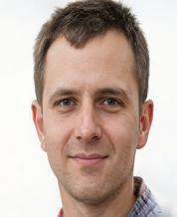 | 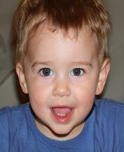
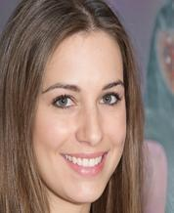 | 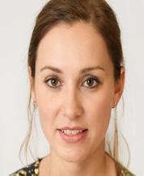 | 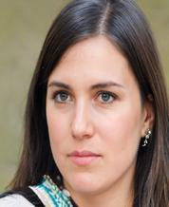
Fig.4: thispersondoesnotexist.10k Dataset
2.2.2 Number of Samples:
- The dataset contains 10,000 synthetic images of unique, non-existent people.
2.2.3 Image Details:
- Resolution: High-resolution images.
- Dimensions: Images are square 1024x1024 pixels, there may be differences.
- Format: Images are commonly provided in JPEG or PNG formats.
2.2.4 Image Content:
- Each image contains a single face, with the following characteristics:
- Diversity in age, gender, ethnicity, and facial features.
- Different hairstyles, accessories, and facial expressions.
- Backgrounds that vary, with some being naturalistic while others are plain or abstract.
- No recurring faces, as all images are unique.
2.2.5 Source of the Dataset:
The images were generated using StyleGAN, a state-of-the-art generative model developed by NVIDIA.
- StyleGAN uses a large dataset of real human faces to train the generative model, ensuring realistic outputs while avoiding the use of actual people's data.
2.2.6 Applications:
This dataset is particularly useful in:
- Face Classification.
- Fraud Detection.
- Data Training.
- Image analysis.
2.2.7 Advantages:
- Privacy Protection.
- High Diversity.
- Ease of Access.
2.2.8 Challenges:
- The images may not always represent realistic diversity due to biases in the data used to train the model.
- The images may contain minor imperfections, such as distortions in facial features, ears, or backgrounds, especially if the model used is less accurate.

2.3 Dataset Preprocessing Steps:
Preprocessing is a fundamental and essential step in preparing a dataset for training machine learning models, especially when dealing with image data. This processing aims to improve the quality of the data and ensure that the images are ready for effective training. Common preprocessing steps include scaling, where the dimensions of the images are adjusted to fit the model input, such as resizing. Sometimes, cropping and stretching techniques are used to ensure that the image contains only the important parts of it with extra blank space to fit the desired dimensions. Image normalization is also an important part of preprocessing, where pixel values are converted from the range of 0-255 to the range of 0-1 or -1 to 1 to improve model stability and speed up the training process. Data enhancement techniques such as translation, blurring, and illumination are used to introduce additional diversity into the dataset, which helps improve model accuracy. It is also important to reduce noise using image filtering techniques to improve image quality, as well as sometimes converting colors. In some applications, it may be necessary to remove the background from images to highlight only objects or faces. Finally, class balancing techniques may be used to ensure that samples are balanced between different classes in the data. These steps greatly contribute to preparing the data to train the model more accurately and efficiently, which improves the model’s performance in dealing with real data. Below are the common preprocessing steps, tailored to general datasets and specific to images.

    - Collect and Load Data
Description: This step involves collecting the images that need to be processed and uploading them to the work environment.
Process: Make sure that all images stored in the specified folders are accessible. It is preferable to organize the images into separate folders based on category (e.g. a folder for real images and another for fake images).

    - Renaming files
Description: To make it easier to classify images, files can be renamed so that they follow a logical order.
Process: Prefix with a serial number to each image.
Create a CSV file containing the image paths with the category label associated with each image.

    - Uniform Image Resizing
Description: Since images can be of different sizes, they must be reduced to a fixed size so that they can be easily scrolled through the form.
Process: Define a minimum size among all images, then resize the images to fit that size. Techniques such as maintaining the aspect ratio when resizing or resizing directly to the target dimensions are used.
2.3.4 Data normalization
Description: Some neural networks require that the values ​​within the image (pixel values) be in a certain range (e.g. between 0 and 1).
Process: Convert the values ​​to the range [0, 1] by dividing the pixel values ​​by
    - Image to Array Conversion
Description: Convert images to matrices that can be used for training.
Process: Using numpy to convert images to multidimensional matrices.

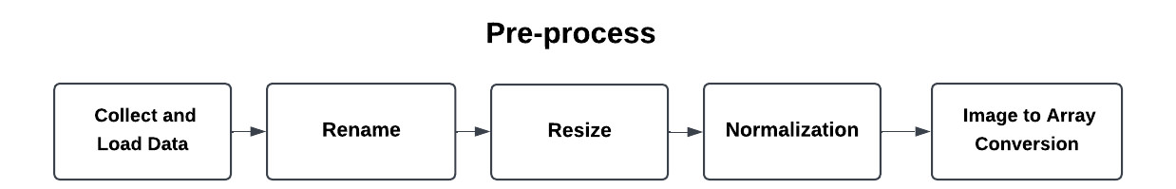

CH 3. METHODOLOGY

3.1 Methodology Framework.
This project aims to build an AI model capable of classifying images into two categories: “human” and “robot”. Deep learning was chosen to design the model because of its high ability to handle large and complex image data, as it can extract complex features that humans cannot manually identify. The model aims to distinguish between the human that appears in the images and artificial robots that may be created using techniques such as generative AI.
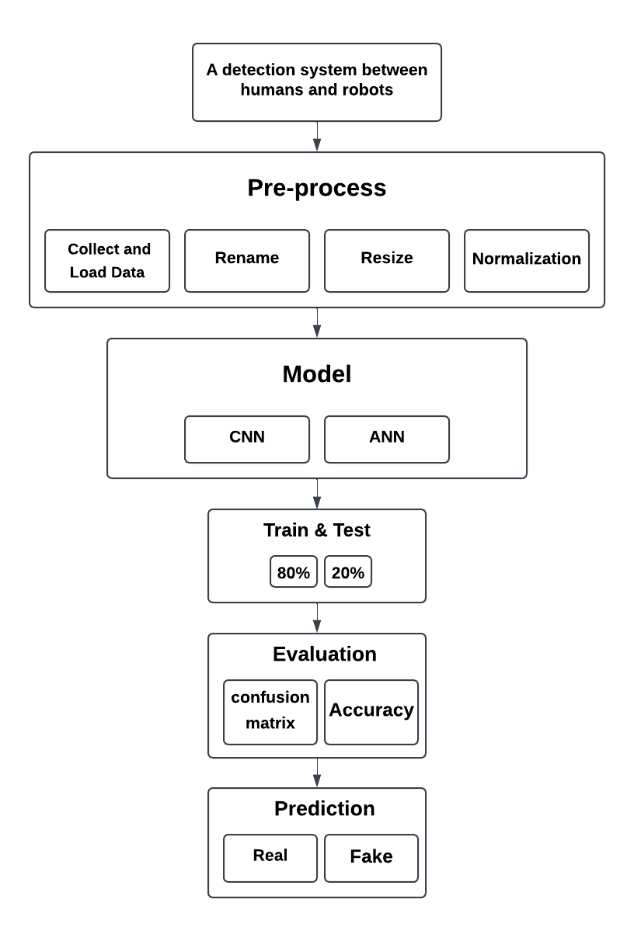
Fig.5: A detection system between humans and robots (DR).
3.1.1: General Methodology
The code aims to process and classify images using deep learning techniques via various Python libraries such as PIL, Keras, Flask, and Streamlit. The process starts by scaling images in two folders containing real and fake images to the smallest common size using the get_min_size function, then the images are resized using the resize_images function with the Image.LANCZOS method to maintain image quality. After that, the images are renamed using specific prefixes (“r” for real images and “f” for fake images) and the image paths along with their labels are saved in a CSV file using the rename_and_save function.
The code builds a classification model using Convolutional Neural Networks (CNNs) via the Keras library, where the images are processed and transformed into the appropriate shape for the model via the preprocess_image and preprocess_images_and_labels functions. The model is trained using the data from the CSV file, and the trained model is saved. Next, the trained model is tested to classify new images as “real” or “fake”, where the model is loaded using Keras and the preprocess_image function is applied to prepare the images before prediction. The class is determined based on the result produced by the model. The code also includes a web application using Flask that allows the user to upload an image and get the prediction using the trained model, where the image is processed and the result is returned as a JSON response. Finally, an interactive web application is provided using Streamlit that allows the user to upload images and classify them easily, with the results displayed on a visually appealing UI, providing a convenient experience for the user to classify images as “real” or “fake”.
3.1.2 System Design
The system is designed based on Convolutional Neural Networks (CNNs), which have exceptional ability to process images and understand the complex gradients that appear in them. Recent studies have shown that Convolutional Neural Networks outperform other techniques such as Multilayer Neural Networks (MLPs) in image classification. CNNs are ideal for analyzing sensory data such as images and videos, thanks to their ability to extract automatic features without the need for human intervention. The system is divided into multiple stages starting with data collection, followed by initial data processing, then training using a CNN model and finally evaluation using accurate metrics such as Accuracy and Confusion Matrix.[14]
3.1.3 Data Selection
Data selection was one of the most important stages of building the model. Two main datasets were used:
CelebA Dataset: This dataset contains millions of images of human faces, and is primarily used to train the model to recognize human faces. [15]
ThisPersonDoesNotExist Dataset: This dataset contains images generated using generative AI models such as Generative Adversarial Networks (GANs), and represents bots or fake characters.
The dataset was divided into training sets and test sets. 80% of the data was used to train the model, while 20% was allocated for testing.[15]

3.1.4 Model:

    - Model Creation
Description: After preparing the data, the model (such as CNN) can now be created.
Process: Define the model layers such as Conv2D, MaxPooling2D, Flatten, and Dense.

    - Model Training
Description: Train the model using the trained dataset.
Process: Use model.fit to train the model using the fitted images and labels.

    - Model Evaluation
Description: After training, you need to evaluate the model using the test set.
Process: Use model.evaluate to get the model's accuracy and performance on unseen data.

    - Prediction
Description: Use the trained model to predict new image classes.
Process: Load the new image, process it, and then predict it using model.predict.

    - Model Tuning
Description: You can improve the model by adjusting parameters such as the number of layers, size, or learning rate.
Continuous Evaluation: Continuously verify the accuracy of the model on data through graphical analysis and experimentation.

3.1.5 Algorithm selection
The rationale behind choosing Convolutional Neural Networks (CNNs) is their high efficiency in image classification and the ability to extract features across multiple layers. Convolutional neural networks include several convolutional layers, followed by Pooling layers and Fully Connected Layers. Adam algorithm was used as an optimization method to update weights during training. Adam was chosen because it combines the advantages of Momentum and RMSprop, which helps to speed up the training process and achieve stability.[17]
3.1.6 Evaluation
The confusion matrix and accuracy were used to evaluate the model. Accuracy is calculated by comparing the actual classifications with the predictions made by the model, while the confusion matrix shows the ability of the model to distinguish between classes with greater accuracy. The matrix includes results such as sensitivity, precision, and recall.[18]

3.2 Model Architecture and Description.
3.2.1 General description of the model:
Inputs:
The input data for this project are images that are used whether the picture shown is a robot or a human, The images are images of people's faces, whether a robot or a human, Images are prepared to fit the model used (data preprocessing)

3.2.2 Explanation of the model layers:
1. Convolutional Layers:
- Conv2D(32, (3, 3), activation='relu'):
- Contains 32 filters, each with dimensions 3×3.
- Applies the activation function ReLU (Rectified Linear Unit) to eliminate negative values, speeding up training and improving performance.
- Conv2D(64, (3, 3), activation='relu'):
- Contains 64 filters, increasing the depth of the extracted features.
2. Pooling Layers:
- MaxPooling2D((2, 2)):
Reduce the dimensions of the data using the Max Pooling method with a 2×2 matrix.
3. Fully Connected Layers:
- Dense (128, activation='relu')
- contains 128 neurons with ReLU activation function
- Dropout (0.5):
- Randomly drops 50% of the connections during training to avoid overfitting.
- Dense (1, activation='sigmoid')
- Contains a single neuron to produce the final output (Real or Fake) using the Sigmoid activation function to generate a probability between 0 and 1.
3.2.3 Libraries used:
1 TensorFlow/Keras.
- Description: An open-source deep learning library used for building and training neural networks.

* Usage:
- Importing layers needed to create the neural network model (e.g., Conv2D, MaxPooling2D, Dense, and Dropout).
- Training the model using fit.
- Loading the trained model with load_model.
- Using the Adam optimizer and binary_crossentropy loss function.
2 Pillow (PIL)
- Description: A library for image processing.
* Usage:
- Opening images using Image.open.
- Resizing images while maintaining their aspect ratio with thumbnail.
- Processing images by creating a blank canvas to unify dimensions using Image.new and placing images on it with paste.
3 NumPy
- Description: A library for handling arrays and numerical operations.
* Usage:
- Converting images to arrays using np.array.
- Normalizing image values to the range [0, 1].
- Expanding image dimensions to add a batch dimension using np.expand_dims.
4 Pandas
- Description: A library for data analysis and working with CSV files.
* Usage:
- Reading image data and paths from a CSV file using pd.read_csv.
- Accessing image paths and labels.
5 Flask
- Description: A web development framework for Python.
* Usage:
- Creating an API endpoint for uploading images and obtaining predictions from the model.
- Handling HTTP requests via the /predict route.
6 Streamlit
Description: A library for building interactive user interfaces for AI and data science applications.
* Usage:
- Building a simple and user-friendly interface for uploading images and displaying results.
- Showing uploaded images with final predictions (Real or Fake) and confidence details.
7 os
- Description: A standard library for interacting with the file system.
* Usage:
- Checking the existence of image files using os.path.exists.
- Normalizing file path formats with os.path.normpath.

3.3 Background on the Used Algorithms.
3.1 Description of the algorithms used:
Several algorithms and techniques were utilized for image processing, neural networks, and data classification. The key algorithms and techniques include:

3.1.1 Convolutional Neural Network (CNN):
Building the CNN model:
- Convolutional Layers (Conv2D):
  - The first layer contains 32 filters of size (3x3) with the "ReLU" activation function, used to extract features from the image. The kernel initializer='he_normal' is used to initialize the weights effectively.
  - The second layer contains 64 filters of size (3x3) with "ReLU" activation.
  - The third layer contains 128 filters of size (3x3) with "ReLU" activation.
All convolutional layers are followed by MaxPooling2D layers, which are used to down sample the feature maps and retain the most important information.
- Other Layers:
  - After the convolutional layers, a Flatten layer is used to convert the output into a one-dimensional vector that can be fed into the fully connected layers.
  - A Dense layer with 128 units and "ReLU" activation enhances the model’s learning capacity.
  - A Dropout layer with a rate of 0.3 is added to reduce the risk of overfitting by randomly dropping units during training.
- Final Layer:
  - The final layer is a Dense layer with a single unit and "sigmoid" activation, which is suitable for binary classification tasks as it outputs a probability between 0 and 1 to decide the class.

Training Process:
- The Adam optimizer is used to update the weights efficiently.
- The binary_crossentropy loss function is chosen, as it is commonly used for binary classification problems.
- The accuracy metric is included to monitor the model’s performance during training.
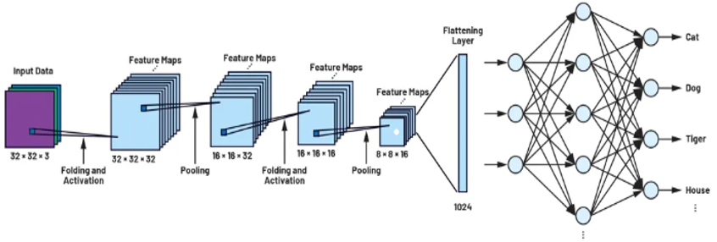
Fig.6: Understanding convolutional neural
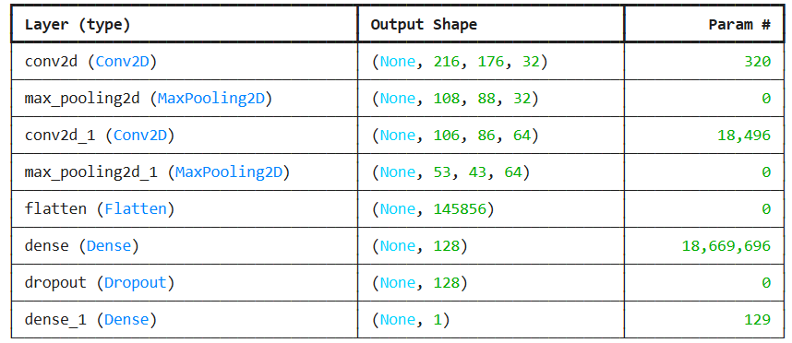
Tabel.1: Model Summary
3.1.2 Adam Optimizer:
Adam is an optimization algorithm used to update model weights during training. It improves upon the traditional Stochastic Gradient Descent (SGD) by incorporating adaptive learning rates and momentum.

3.1.3 Flask API:
Flask is a micro-framework for creating web applications and APIs. It is used to develop an interface that allows the model to receive image inputs and return predictions.
3.1.4 Streamlit:
Streamlit is a Python library used to create interactive user interfaces. It provides a user-friendly platform for uploading images and displaying the model's predictions.
3.1.5 Binary Cross-Entropy Loss:
This loss function is used for binary classification tasks. It measures the difference between the predicted probabilities and the actual labels, guiding the model to minimize this difference during training.
3.1.6 Artificial Neural Network:
Building the ANN model:
- Hidden Layers:
  - The first layer is a Dense layer with 128 units and "ReLU" (Rectified Linear Unit) activation. This hidden layer learns the basic patterns in the data. The input shape is defined by input shape, which matches the number of features in the flattened data (data converted from images to 1D vectors).
  - After the first layer, a Dropout layer with a rate of 0.3 is added to reduce overfitting by randomly dropping some units during training.
  - The second layer is another Dense layer with 64 units and "ReLU" activation, enhancing the model's learning capacity.
- Output Layer:
  - The final layer is a Dense layer with a single unit and "sigmoid" activation. The "sigmoid" function is used for binary classification because it outputs a value between 0 and 1, making it easy to classify between the two classes (real/fake).

- Training Process:
- The Adam optimizer is used to efficiently update the weights during training.
- The binary_crossentropy loss function is chosen, as it is suitable for binary classification tasks.
- The accuracy metric is included to measure the model's performance during training, providing a direct evaluation of the model's effectiveness.

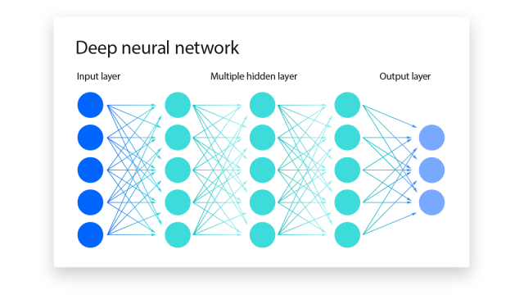
Fig.7: Deep neural network
3.2 Advantages and disadvantages of the algorithms used:
3.2.1 Convolutional Neural Network)CNN):
Advantages: Convolutional neural networks (CNNs) are the best choice for image classification tasks due to their superior ability to process spatial data and extract multiple features from images via convolutional layers. These networks enable accurate pattern recognition through deep learning, which enhances their ability to perform complex tasks. Moreover, CNNs enable the extraction of features automatically during the training process, reducing the need for manual feature engineering that can be complex and time-consuming. On the other hand, when trained on large datasets, CNNs achieve superior performance compared to many other traditional algorithms, especially in areas such as face recognition and classification, making them a powerful tool in AI applications.[19]
Disadvantages: Despite the many advantages that convolutional neural networks (CNNs) offer in image classification tasks, there are some challenges associated with their use. First, the process of training a CNN requires high computational resources, as it can be expensive in terms of computations, requiring powerful hardware such as graphics processing units (GPUs) or specialized chips (TPUs), especially when dealing with large datasets. Second, to achieve good performance, CNNs need large amounts of data to effectively train the model; if the data is insufficient, this can lead to problems such as overgeneralization or overfitting. Finally, despite their high efficiency, CNNs suffer from being “black box” models, which makes it difficult to understand how the model makes decisions. This problem of limited interpretability can be a hindrance in some sensitive applications that require accurate interpretations of the decisions made by the model.[20]

3.2.2 Binary Cross-Entropy Loss:
Advantages: It is an ideal choice for binary classification tasks, as it focuses specifically on predicting between only two classes, such as distinguishing between “human” and “robot.” This feature is particularly useful in applications that require accurate classification between two contrasting classes. Another notable advantage of binary cross-entropy loss is its sensitivity to errors, as it gives greater penalties for errors that occur when predicting a rare class (such as predicting “robot” instead of “human”), which helps to boost the accuracy of the model and achieve better performance. These sensitivities make it better able to handle imbalanced data, and ensure that the model learns to distinguish between rare classes more effectively.[21]
Disadvantages: It is greatly affected by the distribution of the data, especially if the data is imbalanced, where some classes have more samples than others. In this case, the loss may bias the results towards the most frequent class, reducing the model’s ability to correctly distinguish between rare classes. This can lead to performance degradation, especially when it comes to detecting underrepresented classes such as “robot” in a human-robot classification problem. To overcome this problem, it may be necessary to process the data in a balanced way, such as resampling or using class weights, which help improve performance when dealing with imbalanced data and ensure that the model learns all classes fairly.[22]
3.2.3 Adam Optimizer:
Advantages: An advanced optimization algorithm that uses an adaptive learning rate, which means it adjusts the learning rate based on the historical gradient in the past, allowing the model to be trained faster and more stable compared to traditional algorithms such as stochastic gradient descent (SGD). The Adam optimizer also has strong performance on a variety of problems, including deep neural networks, making it a preferred choice in many deep learning applications. Thanks to its high efficiency, the Adam optimizer does not require fine-tuning of the learning rate, making it easy to implement and execute directly, which enhances its effectiveness in computationally intensive machine learning environments.[23]
Disadvantages: Although Adam optimizer is considered an effective algorithm for improving training, the overall performance of the model may require continuous monitoring, as the adaptive rate can affect generalization in some cases. While Adam improves performance by adapting to the data, some applications may see limited impact in cases where strong generalization of the model to unseen data is required. Additionally, Adam optimizer requires tuning some additional parameters such as momentum settings and correction settings, which can significantly affect its performance in certain cases. This means that its optimal use may require a careful understanding of how these parameters affect the results.[24]
3.2.4 Flask and Streamlit:
Advantages: Both Flask and Streamlit are easy-to-use tools that allow you to create interactive applications for AI projects without the need for deep web development knowledge. Thanks to their simplicity, developers can easily publish models online while providing interactive interfaces, making it easy for users to interact with the models. Additionally, Streamlit supports real-time interactivity, enabling results and predictions to be displayed directly as edits are made or inputs are provided. This feature makes the tools ideal for building interactive interfaces that improve user experience, especially in applications that require immediate response and flexibility in dealing with data.[25]
Disadvantages: Despite the advantages of Flask and Streamlit in developing interactive web applications quickly and easily, limited scalability is a major limitation of these tools. When dealing with large or complex applications, these tools may find it difficult to scale to keep up with increasing performance requirements, which can lead to challenges in handling a large number of users. These tools may also face performance limitations in the event of a high load on the system, as they become unable to process large amounts of data or multiple requests at the same time, which can negatively affect the quality of service and limit the system’s ability to meet the needs of large or complex applications.[26]
3.2.5 Artificial Neural Network:
Advantages : Artificial neural networks are ideal for handling large and complex datasets due to their ability to learn deeply, which makes them effective in applications that require pattern recognition such as images and audio. Neural networks are characterized by their ability to generalize after training, as they can deal with new inputs that have not been presented to them before, which enhances their effectiveness in prediction and analysis. In addition, these networks excel at handling non-linear relationships between inputs and outputs, which makes them suitable for solving complex problems that require non-linear models. Neural networks also have the ability to self-adapt, as they automatically adjust internal weights to improve their performance, which gives them high flexibility and the ability to continuously learn from experience to improve results.
Disadvantage: Artificial neural networks require large amounts of data to train effectively, as lack of data can lead to poor performance or inaccurate results, limiting their effectiveness in cases with limited data. Neural networks also suffer from the “black box” problem, where the decisions they make are difficult to interpret and understand, which is a challenge in sensitive applications such as medicine or law where explainability and transparency are essential. In addition, these networks require intensive computational processing, especially during the training phase, requiring high resources such as powerful processors or advanced graphics processing units, which can increase the costs and time required for development. Finally, neural networks are sensitive to the initial weights that are assigned when training begins, as inappropriate weights can lead to slow learning or even failure to reach the optimal solution.

CH4. RESULTS AND DISCUSSION

4.1 Experimental Setup
4.1.1 Experiment: We adjusted the size of a dataset containing 100 real images and 100 fake images. The size of all images in both categories was 218 in height and 178 in width, which is the smallest size among all images in both sets.
Image Size Distribution:
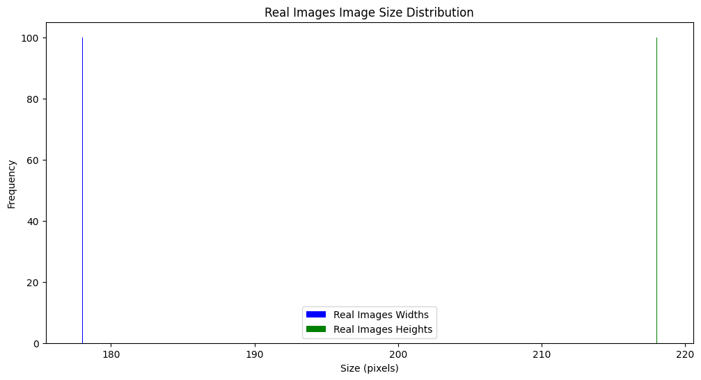
Fig.8: Resizing Fake

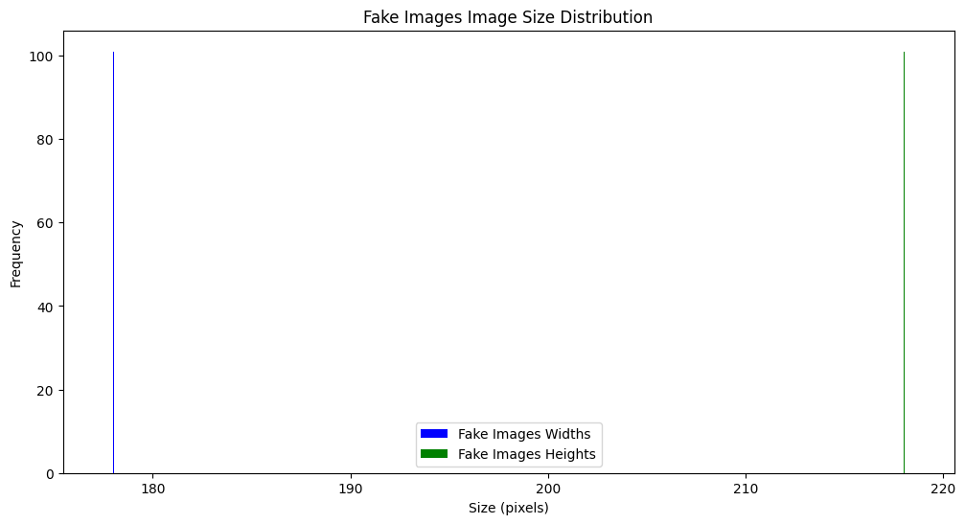
Fig.9: Resizing Real
NOTE: Model with data augmentation
In this experiment, the number of data was increased to 10,000 images per dataset instead of 100 images and the size was adjusted for all images, thus the model was improved and became more accurate in distinguishing between human and robot images.

4.1.2 Experiment: The pixel values were normalized to the range [0, 1] by dividing by 255.
Normalized Images Shape: (201, 218, 178, 3)
Labels Shape: (201,)

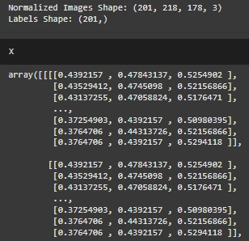

NOTE: Tuning hyperparameters
This experiment involved adjusting parameters such as learning rate, batch size, and number of epochs to determine the best settings to improve the model’s performance.

4.1.3 Experiment: Comparing different architectures
The performance of the model using a simple CNN architecture (two convolutional layers) was compared to an ANN model and it was found that the CNN model was better than the ANN model.
Results of CNN Model: Train accuracy :1.00, Validation accuracy: 1.00, Test accuracy: 0.97, and the graph for both training and verification was:
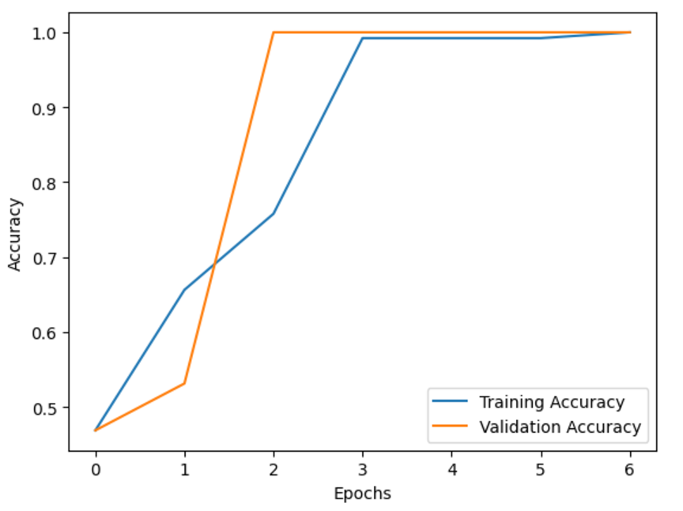
Fig.10: CNN Accuracy
This graph shows the change in loss during the training and validation process of a deep learning model over a number of epochs. The horizontal axis represents the number of epochs, and the vertical axis represents the loss value.
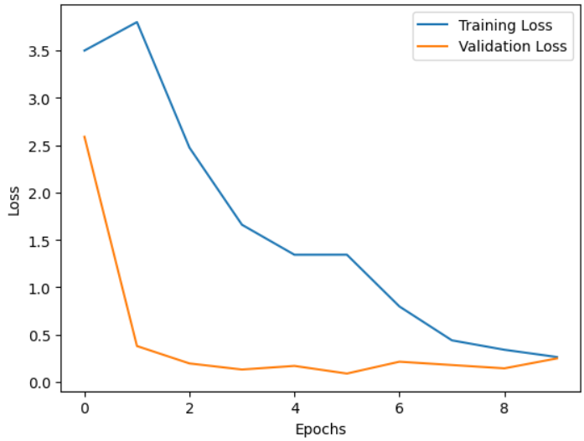
Fig.11: CNN Loss

Results of ANN Model: Train accuracy: 0.88, Validation accuracy: 0.90, Test accuracy: 0.85, and the graph for both training and verification was:
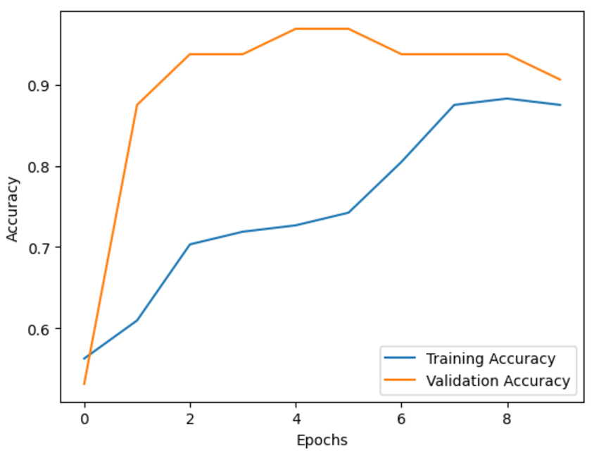
Fig.12: ANN Accuracy
This graph shows the change in loss during the training and validation of a deep learning model over a number of epochs. The horizontal axis represents the number of epochs, and the vertical axis represents the loss value.


Fig.13: ANN Loss
The CNN model better than ANN model.
NOTE: Evaluation on unseen test data
- The model’s ability to generalize was tested by evaluating its performance on a separate test set that it did not see during training or validation.
4.2 Evaluation Metrics
- Accuracy: The ratio of correctly classified samples to the total samples. This is the basic metric for evaluating the overall performance of a model.
- Precision: The ratio of correct positive predictions to the total positive predictions made by the model. It shows how well the positive predictions of the model are correct.
- Recall: The ratio of correct positive predictions to the total actual positive cases. It shows how well the model correctly identifies positive samples.
- F1 score: The harmonic mean between precision and recall, a balanced measure between the two and is especially used when there is an uneven balance in the data.
- Confusion matrix: A matrix showing the true positive and true negative values, as well as the false positive and false negative values. This matrix gives deeper insights into the performance of the model.

precision recall f1-score support

0 0.79 1.00 0.88 22
1 1.00 0.68 0.81 19

accuracy 0.85 41
macro avg 0.89 0.84 0.85 41
weighted avg 0.89 0.85 0.85 41

  - Experiments
4.3.1 Description of the environment:
    - Hardware specifications.
- GPU: NVIDIA Geforce RTX 3050 Laptop GPU.
- CPU: AMD Ryzen 5 5600H Radeon Graphics.
- RAM: 16 GB.

        - Software and frameworks used.
- os: Manipulating files and folders (such as creating, deleting, or reading files).
- csv: A standard Python library for handling CSV files Reading and writing CSV files.
- NumPy: Efficient numerical data processing.
- pandas: A powerful library for data analysis and processing.
- TensorFlow: An open-source library for building and training deep learning models.
- Keras: An API built on TensorFlow to facilitate building deep models.
- streamlit: A library of interactive graphical interfaces for working with data.
- Pillow : A library of interactive graphical interfaces for working with data.
- OpenCV: for image and video processing.
- Scikit-learn: For data analysis and performance measurement.
- Matplotlib and Seaborn: Two libraries for data visualization and display of results.
- Python: 3.12.1
    - Dataset details:
- Dataset size: The dataset consists of images classified into two classes (robot or human). The data is divided into a training set (80%) and a test set (20%).
    - Training Configuration:

- Model Architecture: Convolutional Neural Network (CNN) consisting of two convolutional layers, followed by full pooling layers for image classification.

    - Hyperparameters:

- Learning Rate: 0.001, used to update the model weights during training.
- Batch Size: 32, the number of samples processed before updating the model weights.
- Number of Epochs: 10, the number of times the entire dataset is passed through the model during training.
- The Adam optimizer is used to update the weights efficiently.
- The binary_crossentropy loss function is chosen, as it is commonly used for binary classification problems.
- The accuracy metric is included to monitor the model’s performance during training.
4.3.5 Tools for Experimentation:
- Google Colab , Visual Studio Code: Used for running experiments in a cloud-based environment with access to GPU resources

  - Results Analysis (Visualization and Description)
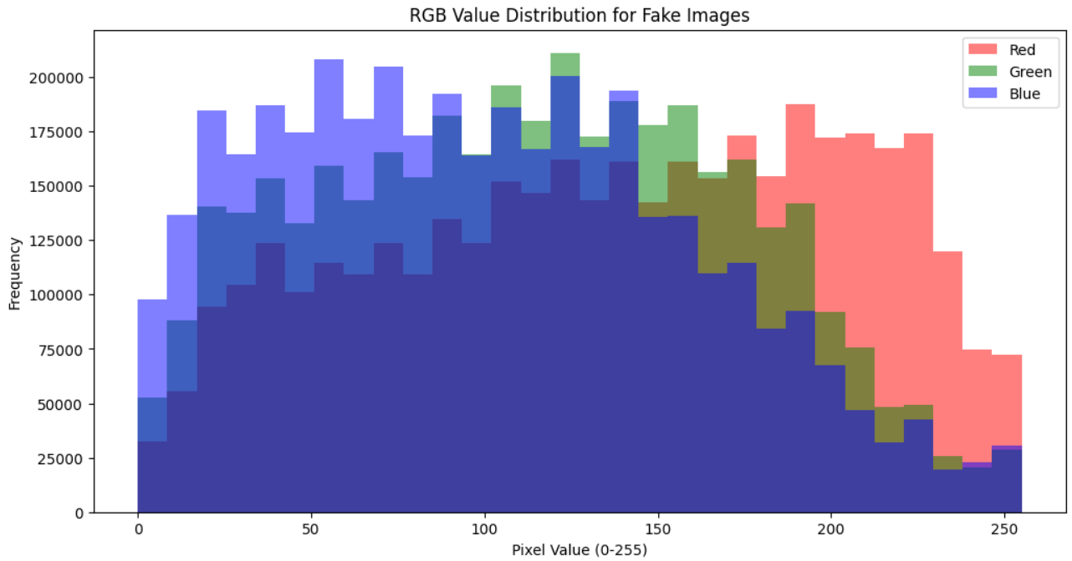
Colour Channel Statistics: Calculate mean, variance, and distribution of RGB values
Fig.14: Fake images color channels
Fake Image Statistics:
Red: {mean: 138.00378010432732, variance: 4360.240989496275}
Green: {mean: 113.76682994812212, variance: 3489.908928100358}
Blue: {mean: 100.44655113640422, variance: 3493.0396776213697}
The image shows the distribution of RGB color values ​​in fake images using a histogram. The graph aims to analyze pixel values ​​in the three primary color components: red, green, and blue. The horizontal axis (X-axis) represents the pixel value ranging from 0 to 255, where "0" indicates black (zero light intensity) and "255" indicates white (maximum light intensity). The vertical axis (Y-axis) represents the frequency of each pixel value, i.e. the number of pixels in the images that contain that color value. The colors in the graph show the distribution of values ​​across the different channels: red, which shows the distribution of pixels for red, green, which shows the distribution of pixels for green, and blue, which shows the distribution of pixels for blue.

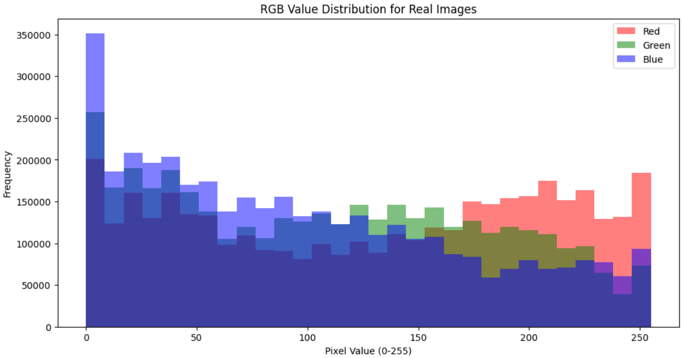
Fig.15: Real images color channels
Real Image Statistics:
Red: {mean: 130.79533269766003, variance: 6273.478758908998}
Green: {mean: 109.15525023193486, variance: 5212.736297581959}
Blue: {mean: 97.57648360993711, variance: 5254.68837301795}}
The image shows a graph showing the distribution of RGB color values ​​in real images using a histogram, which helps in analyzing the distribution of the intensity of the three primary colors: red, green, and blue, in a set of images. The horizontal axis (Pixel Value) represents the pixel values ​​ranging from 0 to 255, where the value "0" indicates black (zero light intensity), the value "255" indicates white (maximum light intensity), while values ​​between 0 and 255 represent different color shades. The vertical axis (Frequency) represents the frequency of occurrence of each pixel value in the images, i.e. the number of pixels that contain a certain value for each of the colors red, green, and blue. The colors in the graph show the distribution of values ​​across the different channels: the red channel shows the distribution of values ​​for red colors, the green channel shows the distribution of values ​​for green colors, and the blue channel shows the distribution of values ​​for blue colors in real images. A key observation is that there is a significant spike at low values ​​(close to zero), indicating that there are many dark pixels in the images, meaning that the real images contain dark areas or shadows. The distribution also becomes more even at higher values ​​(100 to 250), indicating a greater variety of colors and a greater gradation in the images. You will also notice that the Blue channel has higher frequencies overall compared to the other channels, indicating that the images contain more blue than the rest of the colors.
Image Sharpness/Blur Detection: Measure sharpness to identify poor-quality images.
To measure the clarity or blur of images and determine their quality, techniques based on edge or gradient analysis are used, the most prominent of which is Laplacian Variance. This method begins by converting the image to grayscale to reduce complexity and focus only on the light intensity. Then, a Laplacian filter is applied, which calculates the second derivative of the image, which highlights strong edges. Edges are rapid changes in light intensity, and are clear in sharp images and blurry in blurry images. Once the Laplacian filter is applied, the contrast of the resulting image is calculated; it is a measure of how spread out the pixel values ​​are. High contrast indicates strong edges and a clear image, while low contrast indicates a blurry image. This technique is used in many applications such as smart cameras to improve focus, in automatic systems to ensure that the images used are of high quality, in addition to its use in image classification applications to ensure accuracy in the models used.
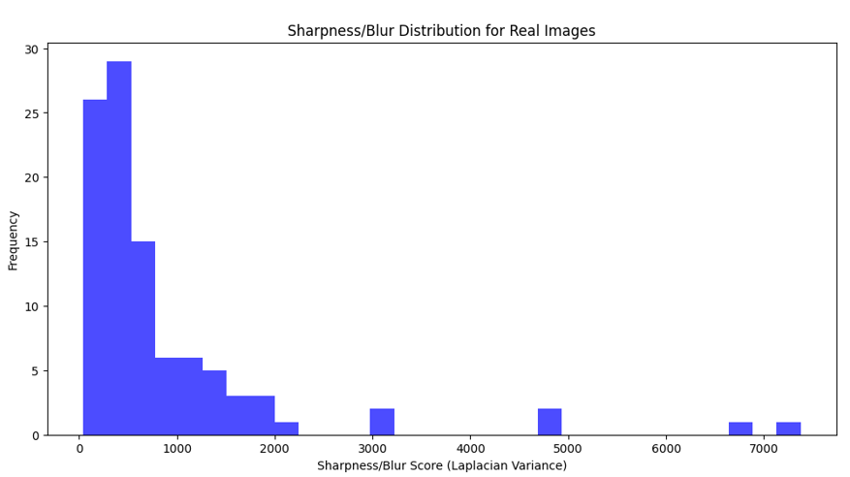
Fig.16: Real Images Sharpness
Real Images: Mean Sharpness: 881.04
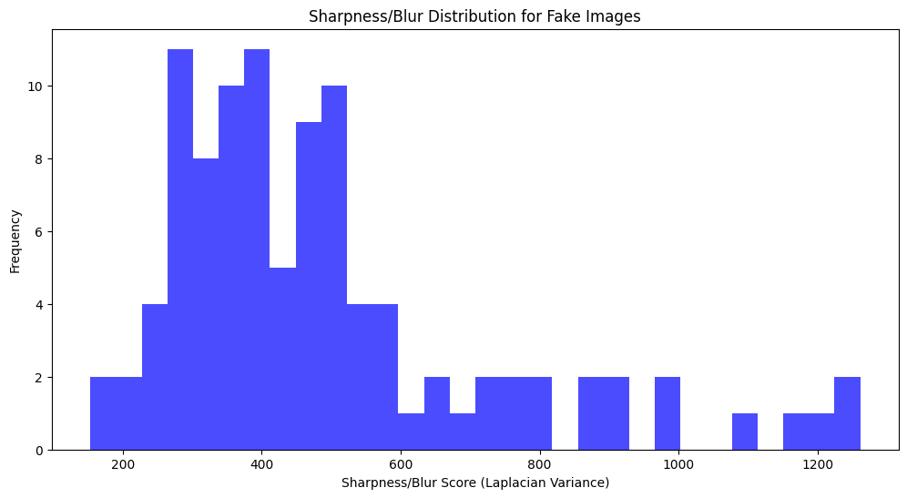
Fig.17: Fake Images Sharpness
Fake Images: Mean Sharpness: 494.01
Pixel Intensity Histograms
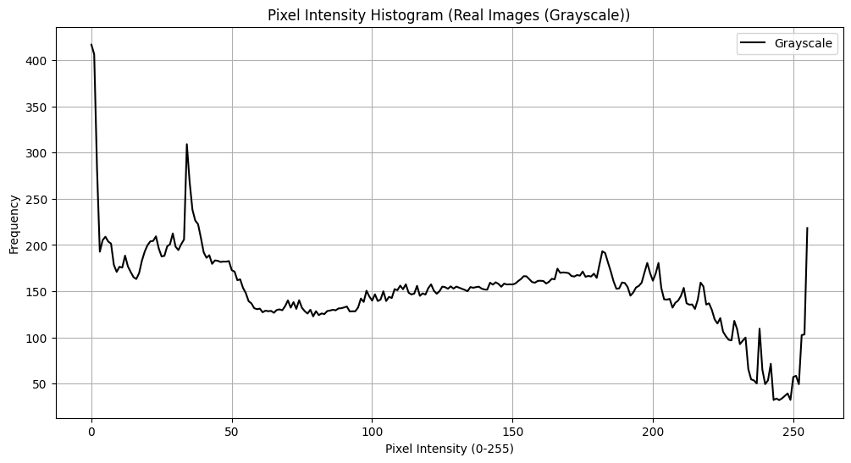
Fig.18: Pixel Intensity Histograms (Real Image(Grayscal))
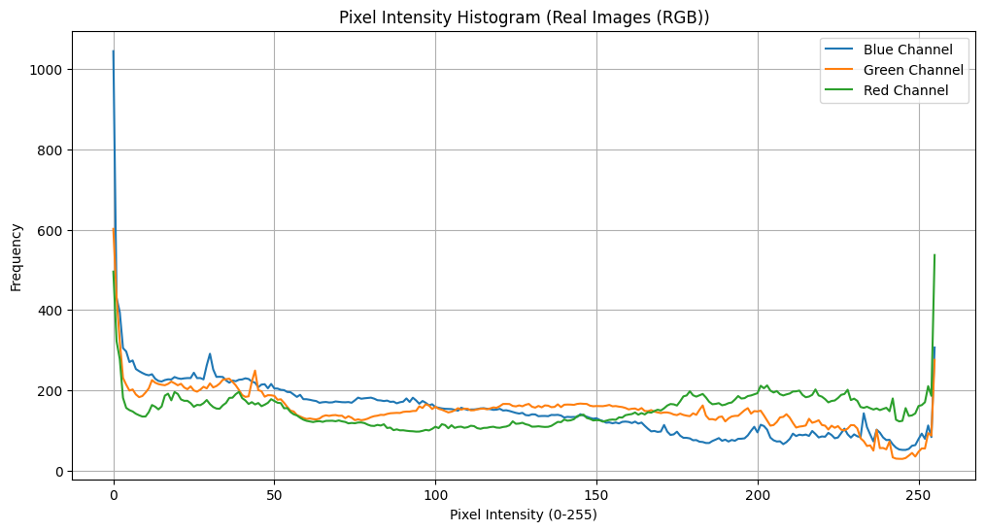
Fig.19: Pixel Intensity Histograms (Real Image (RGB))
In real images:
Gray images, we notice that pixels with value 0 have the highest frequency And are almost close at the rest of the values.
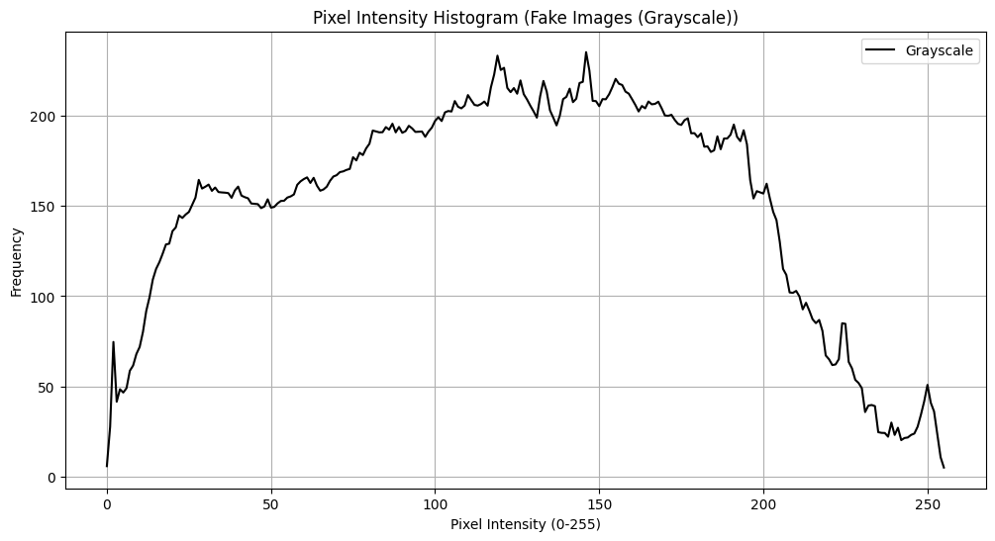
RGB images, we notice that pixels with value 0 have the highest frequency And at value 250 their frequency is different And are almost close at the rest of the values.
Fig.20: Pixel Intensity Histograms (Fake Image (Grayscal))
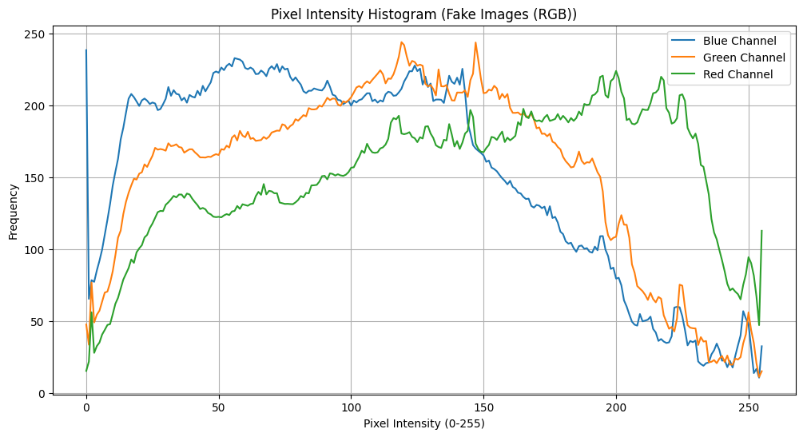
Fig.21: Pixel Intensity Histograms (Fake Image (RGB))
In fake images:
Grayscale images, we notice that the pixels between values ​​50 and 200 have a high and close frequency And a low frequency at values ​​0 and 250
Colour images, we notice that the pixels between values ​​50 and 200 have a high and close frequency in addition to a high frequency at value 0.

Grayscale Conversion: Reduce colour channels
Gray=0.2989⋅R+0.5870⋅G+0.1140⋅B
grayscale = 0.2989 * img_normalized[:, :, 0] + 0.5870 * img_normalized[:, :, 1] + 0.1140 * img_normalized[:, :, 2]

Prepare data for input to the model:
- Create two labels' arrays, one for a fake images array is a zeros array and another for a real images array is a ones array.
- We combined the image and labels arrays to create a single array for data and a single array for labels.
- Mixing data by shuffle and parted the output for training data and test data.
- Add the last dimension to the array because the entered images are grey.

CONCLUSION AND FUTURE RECOMMENDATIONS

Conclusion
This leads us to the concept of our project today, which aims to create a system to distinguish between robots and hum order to avoid falling victim to scams or fraud and raise awareness about how to differentiate between robots and humans online. The goal is to protect society and make it more aware and less susceptible to internet fraud creating an automated model that is able to reliably detect GAN-generated images from real ones. Our approach was based on fine-tuning a pre-trained convolutional neural networks (CNN) model on a newly collected dataset. With the rapid and continuous development of the process of generating images based on artificial intelligence, the generated images have become much closer to being realistic and deceiving the human eyes. This may lead to many dangers arising from deceiving people, whether in societies, companies, universities, social media sites, etc.; Therefore, challenges must be imposed on security and credibility, which made the world create systems to distinguish between robots and humans. There is an important need for an automated tool to detect generated images based on artificial intelligence and real human images. Therefore, this paper proposed an automated model to recognize artificial intelligence-generated images from real images. A large dataset was collected, for both fake images generated by artificial intelligence and real images, based on a variety of GAN-based image synthesis tasks and models, and then a CNN model was trained well on the datasets. Extensive experiments led to a method capable of recognizing images generated by GAN from real images with high accuracy, even with other datasets that our model was not trained on. Therefore, our detector can be used to detect synthetic images from original images. Thus, it can help against malicious or criminal intentions by helping the world from fraud, especially on social media, to counter the threats that may arise from developments in AI image synthesis techniques. Our results indicate that images generated by GANs contain some common defects, distortions, and artifacts that can be exploited to detect synthetic images. These artifacts are invisible to the human eye; however, a well-trained model can easily detect these defects and classify images as synthetic/fake. Therefore, researchers should pay more attention to these artifacts during the image generation process.
In the future, we plan to develop the model on different datasets, including full-body images and not just face images, and also develop it to be able to receive fake or real videos and distinguish between them, as the model is not limited to images only. We plan to include appropriate techniques and strategies to overcome potential hostile attacks to ensure greater security and reliability.

Future Recommendation:
1. Improve model accuracy:
- Increase the size and diversity of the dataset: Collect more images from different sources, including images generated using the latest AI techniques, to ensure that the model can generalize better.
- Use more advanced models: Try deeper models such as ResNet, EfficientNet, or even improved Transformer models to improve model performance.

2. Develop real-time detection tools:
- Integrate the model into web or mobile applications: Develop applications that allow users to upload images to verify whether they are real or AI-generated in real time.
- Use optimization techniques: Improve the prediction speed of the model to ensure fast performance when applied to applications or mobile devices.

3. Expand data types:
- Video detection: Expand the model to include videos generated by AI, as it has become easy to create fake videos that can be devastating in social and political contexts.
- Texts and conversations: Build similar models to recognize texts generated by AI (such as automated conversations) to ensure cybersecurity and privacy protection.
4. Integration with cybersecurity systems:
- Integrating the model with cybersecurity platforms: Developing programming interfaces (APIs) that allow the model to be integrated into information security systems to protect users from deceptive AI-generated content.
- Continuous model updating: Providing mechanisms to update the model periodically to keep pace with the ongoing developments in image generation technologies.
5. Promoting awareness and training:
- Workshops and training: Organizing workshops and training programs to educate the public and companies on how to distinguish between real and fake images.
- Producing educational content: Developing educational materials such as videos and articles to educate users about the risks of AI-generated images and how to deal with them.
6. Research and development:
- Gap analysis: Studying failure cases that the model may fall into to continuously improve it.
- Developing interpretive models: Focusing on developing models capable of explaining their decisions to help increase confidence in them and clarify how to distinguish between images.

LIST OF FIGURES

Fig1: Human or Robot Image…………………………………….………………………..………… 8
Fig2: Fake faces generated by StyleGAN………………….……………………………………9
Fig3: Celebrity Faces Dataset. ……………………………………………………….………….…13
Fig4: thispersondoesnotexist.10k Dataset ……………..……………………….…………….16
Fig.5: A detection system between humans and robots (DR)…………….……………26
Fig.6: Understanding convolutional neural…………………………………………….34
Fig.7: Deep neural network………………..…………………………………………….……………36
Fig.8: Resizing Fake……………………………………………..………………………….……………42
Fig.9: Resizing Real……………………………….………………………………………….………….42
Fig.10: CNN Accuracy………………….………………………………………………………………44
Fig.11: CNN Loss…………………………………………………………………………………………44
Fig.12: ANN Accuracy……………….…………………………………………………………………45
Fig.13: ANN Loss……………………………………………………………………………………………45
Fig.14: Fake images color channels…………………………………..……………………….….49
Fig.15: Real images color channels …………………………….…………………………………50
Fig.16: Real Images Sharpness …………………………………………..…………………………52
Fig.17: Fake Images Sharpness ……………………………………………………………………..52
Fig.18: Pixel Intensity Histograms (Real Image(Grayscal))………….………………..53
Fig.19: Pixel Intensity Histograms (Real Image (RGB)) …………………………….…53
Fig.20: Pixel Intensity Histograms (Fake Image (Grayscal))……………….……..….54
Fig.21: Pixel Intensity Histograms (Fake Image(RGB))……….…………………….…54
CHAPTER PAGE

REFERENCES
[1] | Bilgiç, Emirhan. "AI Ethics, We Are About to Be Late." Kaggle, 2023.
[2] | Baraheem, S.S.; Nguyen, T.V. AI vs. AI: Can AI Detect AI-Generated Images? J. Imaging 199, 9, 2023.
[3] | Goodfellow, I.J.; Pouget-Abadie, J.; Mirza, M.; Xu, B.; Warde-Farley, D.; Ozair, S.; Courville, A.; Bengio, Y. Generative adversarial nets. In Proceedings of the 27th International Conference on Neural Information Processing Systems, Montreal, QC, Canada, 8–13 December 2014; Volume 2, pp. 2672–2680.
[4] | J. Parvizi et al., “Electrical stimulation of human fusiform faceselective regions distorts face perception,” J. Neurosci., vol. 32, no. 43, pp. 14915–14920, 2012
[5] | A. Melnik et al., “Systems, subjects, sessions: To what extent do these factors influence EEG data?,” Front. Hum. Neurosci., vol. 11, 2017, Art. no. 150.
[6] | Larabel, Michael. "NVIDIA Opens Up The Code To StyleGAN - Create Your Own AI Family Portraits." Phoronix, 2019.
[7] | Melnik, A., Miasayedzenkau, M., Makarovets, D., Pirshtuk, D., Akbulut, E., Holzmann, D., Renusch, T., Reichert, G., & Ritter, H. (2024). Face Generation and Editing with StyleGAN: A Survey. IEEE Transactions on Pattern Analysis and Machine Intelligence, 46(5), 3557-3576.
[8] | T. T. Nguyen et al., “Deep learning for deepfakes creation and detection: A survey,” Comput. Vis. Image Understanding, vol. 223, 2022, Art. no. 103525
[9] | ] Y. Mirsky and W. Lee, “The creation and detection of deepfakes: A survey,” ACM Comput. Surv., vol. 54, no. 1, pp. 1–41, 2021.
[10] | ] “D. nostalgia,” Accessed: Sep. 18, 2022. [Online]. Available: https:// www.myheritage.com/deep-nostalgia
[11] | ] C. Yang and S.-N. Lim, “Unconstrained facial expression transfer using style-based generator,” 2019, arXiv: 1912.06253
[12] | E. Burkov, I. Pasechnik, A. Grigorev, and V. Lempitsky, “Neural head reenactment with latent pose descriptors,” in Proc. IEEE/CVF Conf. Comput. Vis. Pattern Recognit., 2020, pp. 13783–13792
[13] | ] J. R. A. Moniz, C. Beckham, S. Rajotte, S. Honari, and C. Pal, “Unsupervised depth estimation, 3D face rotation and replacement,” in Proc. Adv. Neural Inf. Process. Syst., 2018, pp. 9759–9769.
[14] | Lecun, Y., Bengio, Y., & Hinton, G. (2015). Deep learning. Nature, 521(7553), 436-444.
[15] | Liu, Z., et al. (2015). Deep Learning Face Attributes in the Wild. Proceedings of the IEEE International Conference on Computer Vision (ICCV).
[17] | Kingma, D. P., & Ba, J. (2015). Adam: A Method for Stochastic Optimization. International Conference on Learning Representations (ICLR).
[18] | He, K., Zhang, X., Ren, S., & Sun, J. (2016). Deep Residual Learning for Image Recognition. Proceedings of the IEEE Conference on Computer Vision and Pattern Recognition (CVPR).
[19] | Lecun, Y., Bengio, Y., & Hinton, G. (2015). Deep learning. Nature, 521(7553), 436-444.
[20] | Simonyan, K., & Zisserman, A. (2015). Very Deep Convolutional Networks for Large-Scale Image Recognition
[21] | Rojas, R. (1996). Neural Networks: A Systematic Introduction. Springer.
[22] | Zhang, Y., & Zhou, Z. (2016). A Survey on Loss Functions for Classification. IEEE Access
[23] | Kingma, D. P., & Ba, J. (2015). Adam: A Method for Stochastic Optimization.
[24] | Reddi, S. J., et al. (2018). On the Convergence of Adam and Beyond
[25] | Chen, T., et al. (2020). Streamlit: The fastest way to build and share data apps
[26] | Grinberg, M. (2018). Flask Web Development: Developing Web Applications with Python.

